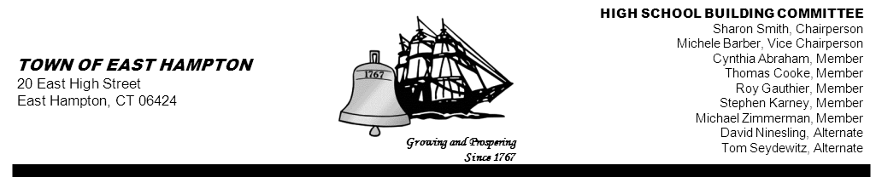

HIGH SCHOOL—ADDITION & RENOVATE-AS-NEW
BUILDING COMMITTEE MEETING
High School (Library)
15 North Maple Street, East Hampton, CT 06424
AGENDA
Thursday, February 21, 2013, 6:30 p.m.

- Call to order

- Public Remarks

- Review and approve minutes from 02-14-2013

- Presentation of Building Project by CREC, SLAM and Downes Construction

- Approval of change order to SLAM contract(inclusion of PCB testing by Fuss and O’Neill)and increase to Eagle contract to include additional testing

- Schedule Overview

- Public Remarks

- Adjournment

cc: John Fidler Jeff Jylkka Amy Christmas
Kevin Reich James Giuliano Amy Samulson
Glenn Gemma Glenn Gollenberg Rick Herzer
Keith Klemonski Sandra Wieleba (for posting) Paul Wojtowicz
Michael Maniscalco Cathy Sirois (for posting) Michael MacDonald
Susan Weintraub Mark Winzler

